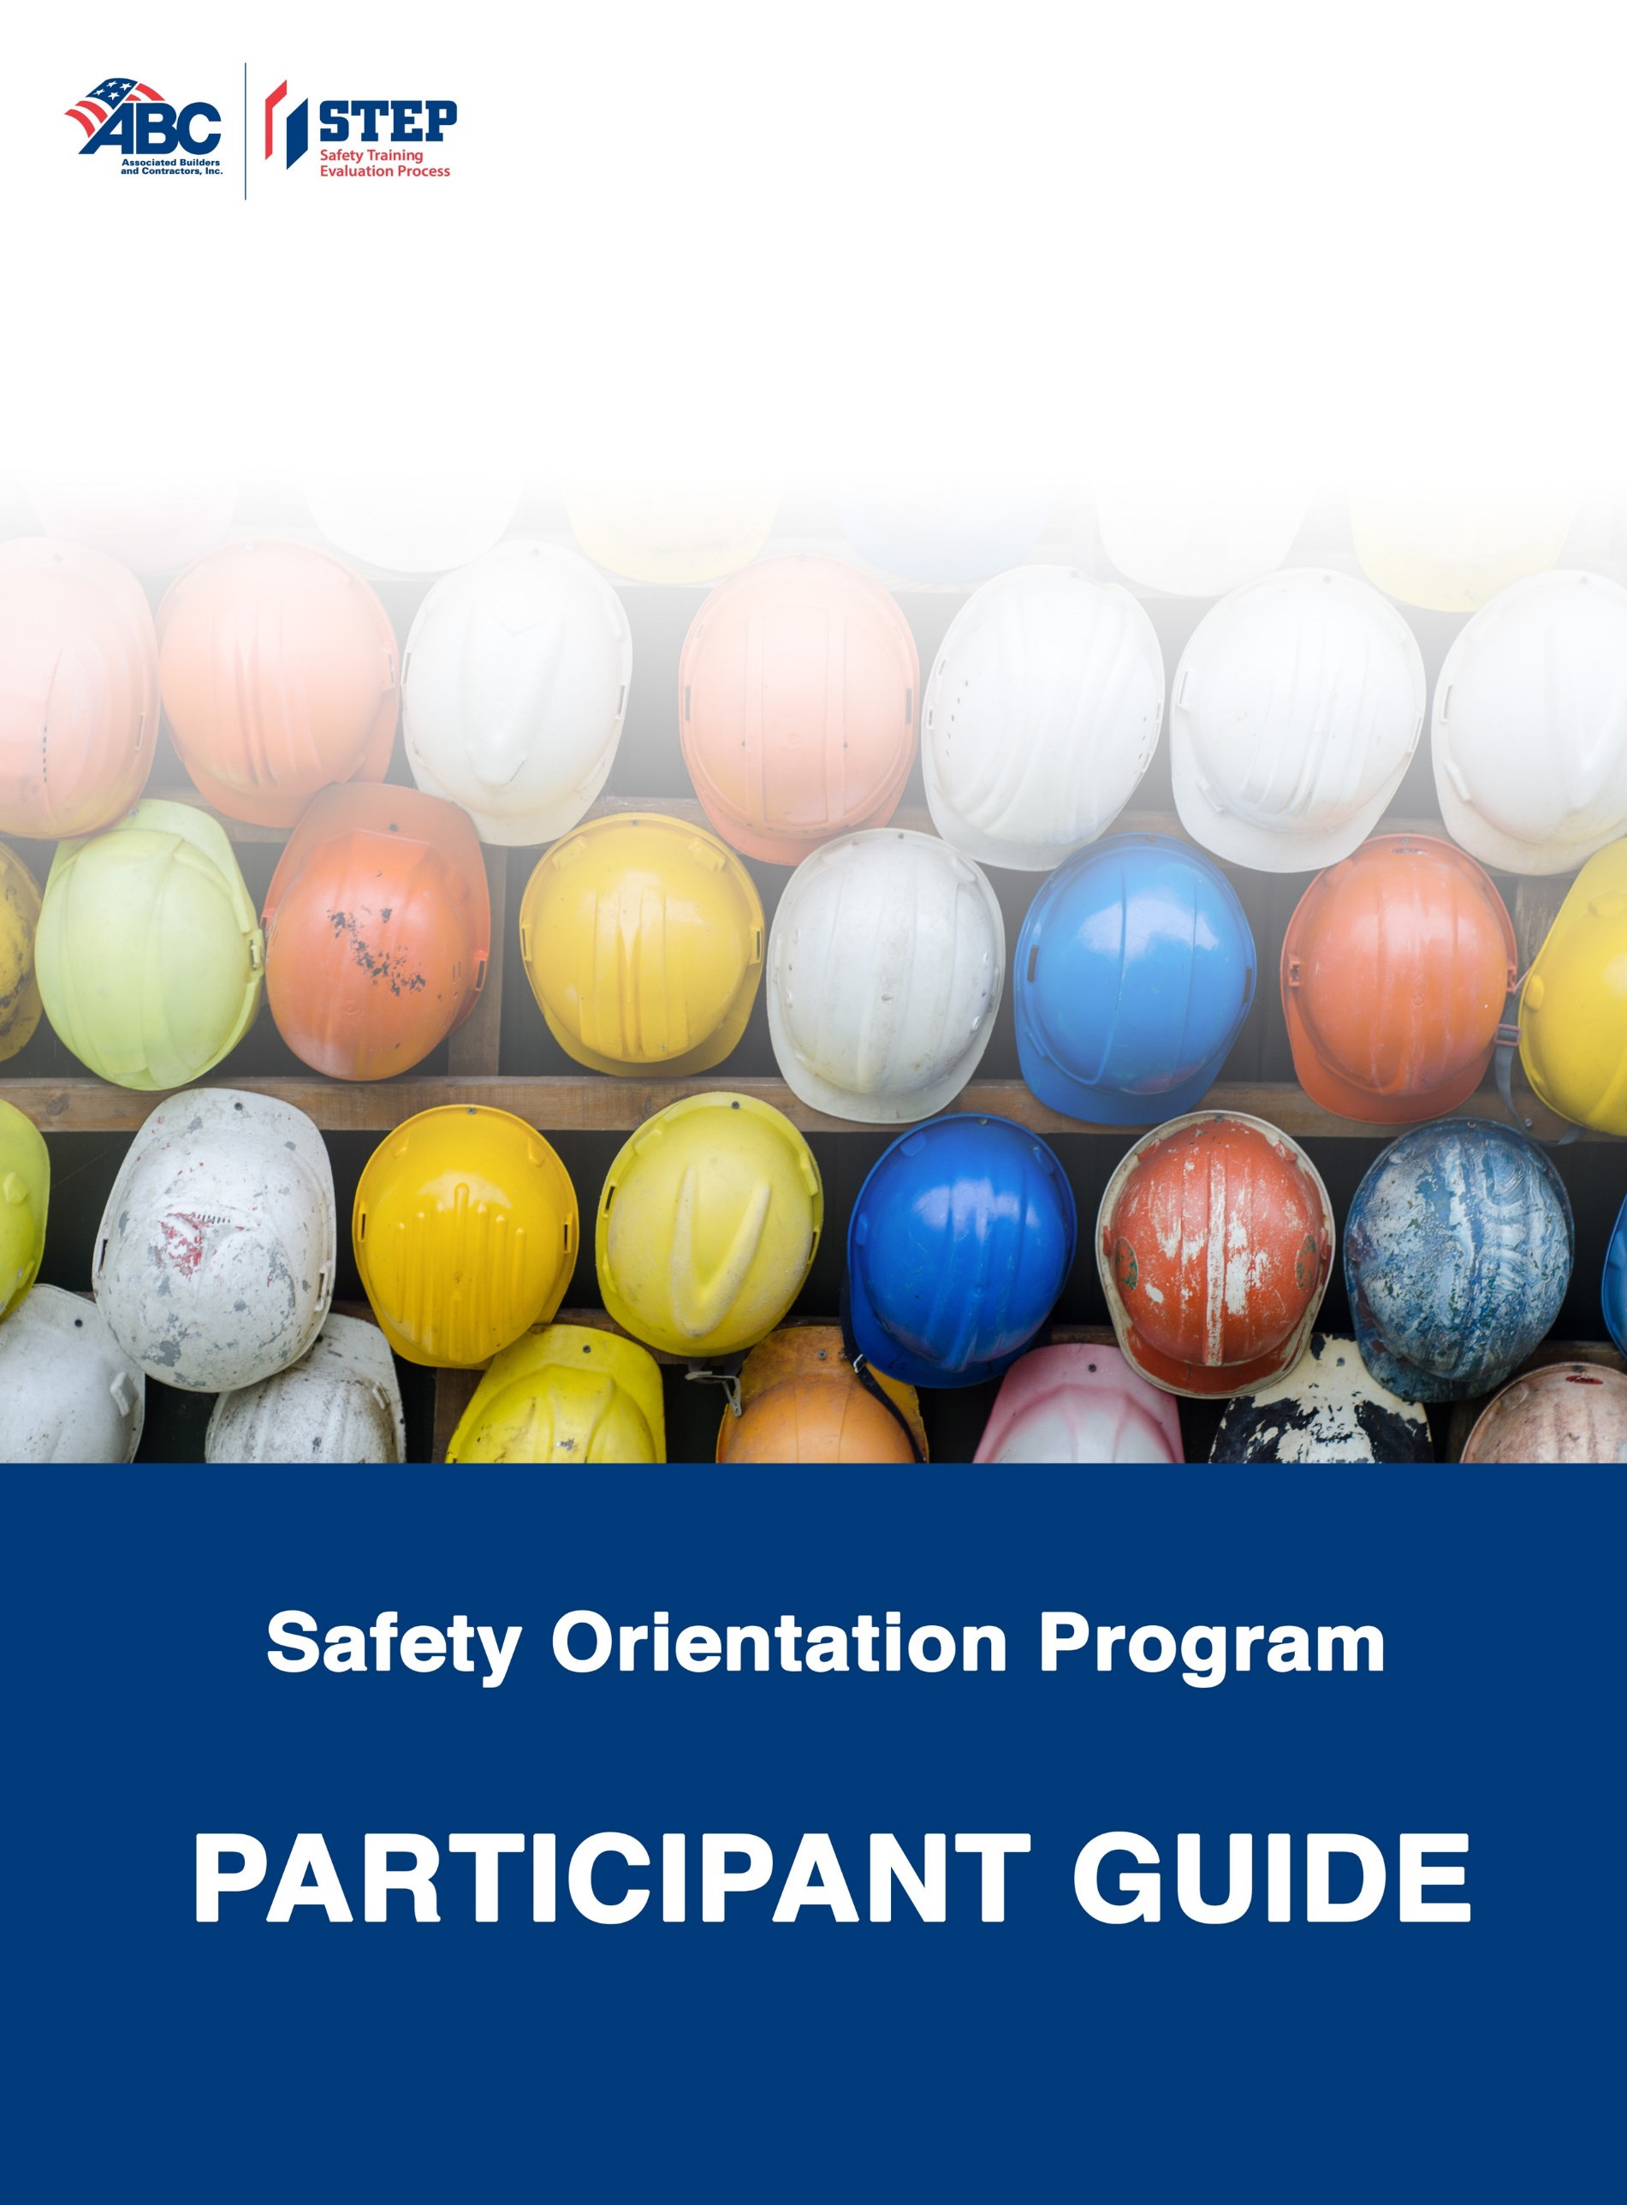
Table of Contents

About ABC 3
About <INSERT COMPANY NAME> 3
About the Safety Orientation Program 3
Special Thanks 4
Safety Orientation Learning Outcomes 5
Safety Orientation Agenda 6
Safety Orientation Program Slides 7
Acknowledgement of Safety Orientation Program Completion 8
Acknowledgement of Safety Orientation Program Completion 9

About ABC

Associated Builders and Contractors (ABC) is a national construction industry trade association representing more than 21,000 members. Founded on the merit shop philosophy, ABC and its 70 chapters help members develop people, win work and deliver that work safely, ethically and profitably for the betterment of the communities in which ABC and its members work. ABC's membership represents all specialties within the U.S. construction industry and is comprised primarily of firms that perform work in the industrial and commercial sectors.

- ABC is the merit shop construction industry's voice with the legislative, executive and judicial branches of the federal government and with state and local governments, as well as with the news media.
- ABC's mission is the advancement of the merit shop construction philosophy, which encourages open competition and a free enterprise approach that awards contracts based solely on merit, regardless of labor affiliation.
- ABC's objective is to deal with issues on an industry-wide basis through its national office and chapters.
- ABC's activities include government representation, legal advocacy, education, workforce development, communications, technology, recognition through national and chapter awards programs, employee benefits, information on best practices, and business development through an online contractor search directory.

ABC was founded in 1950 when seven contractors gathered in Baltimore, Md., to create an association based on the shared belief that construction projects should be awarded on merit to the most qualified and responsible low bidders. The courage and dedication of those seven contractors helped to quickly spread the merit shop. Today, ABC is recognized as one of the leading organizations representing America's business community and the merit shop construction industry.

About <INSERT COMPANY NAME>

< customize with information about your company, including any
information or facts participants should know >

About the Safety Orientation Program

< customize with content regarding your program’s goals, expectations,
and other important information >

Special Thanks

ABC thanks the following volunteers who contributed their time and expertise to the development of the Safety Orientation Program:

Christopher Diaz
Balfour Beatty

Ken Kyle
Rinaldi Group

Jim Thompson
Kwest Group

Safety Orientation Learning Outcomes
Customize this page with the learning outcomes you set for each of the sections you will cover.

Topic
Introductions
Section 1: Safety Leadership

Section 2: Project Specific Safety Guidelines

Section 3: General Worksite Safety

Section 4: Occupational Health and Wellness

Section 5: Personal Protective Equipment

Section 6: Fall Protection/Working at Heights

Section 7: Fire Safety

Section 8: Equipment and Tools

Section 9: Working Over or Near Water

Section 10: Electrical Safety

Section 11: Road Safety

Section 12: Excavation and Trenching

Section 13: Permits

Section 14: Concrete Construction

Section 15: Steel Erection

Conclusion and Final Questions

Safety Orientation Agenda

Topic | Time
Introductions
Section 1: Safety Leadership
Section 2: Project Specific Safety Guidelines
Section 3: General Worksite Safety
Section 4: Occupational Health and Wellness
Section 5: Personal Protective Equipment
Section 6: Fall Protection/Working at Heights
Section 7: Fire Safety
Section 8: Equipment and Tools
Section 9: Working Over or Near Water
Section 10: Electrical Safety
Section 11: Road Safety
Section 12: Excavation and Trenching
Section 13: Permits
Section 14: Concrete Construction
Section 15: Steel Erection
Conclusion and Final Questions

Acknowledgement of Safety Orientation Program Completion

Employee/Contractor Name:

Facilitator Name:

Company Name:

Emergency Contact / Voluntary Medical Information

Emergency Contact Name:

Emergency Contact Phone Number:

Relationship:

The signature on this document represents that the employee/contractor has participated in the safety orientation program and has discussed to his/her satisfaction the content presented. The employee/contractor accepts responsibility for his/her role in maintaining a safe work environment.

Employee Signature Date

Return one copy of the Acknowledgement of Safety Orientation Program Completion to your facilitator and retain one copy for your records.

Acknowledgement of Safety Orientation Program Completion

Employee/Contractor Name:

Facilitator Name:

Company Name:

Emergency Contact / Voluntary Medical Information

Emergency Contact Name:

Emergency Contact Phone Number:

Relationship:

The signature on this document represents that the employee/contractor has participated in the safety orientation program and has discussed to his/her satisfaction the content presented. The employee/contractor accepts responsibility for his/her role in maintaining a safe work environment.

Employee Signature Date

Return one copy of the Acknowledgement of Safety Orientation Program Completion to your facilitator and retain one copy for your records.

Safety Orientation Program Evaluation

Name (optional)

Instructor Name

Date:

Rating
Circle the number that corresponds with your rating.
1 = strongly disagree 2 = disagree 3 = agree 4 = strongly agree

The course objectives were clear. | 1 | 2 | 3 | 4 | N/A
The content was well-organized. | 1 | 2 | 3 | 4 | N/A
The content was comprehensive. | 1 | 2 | 3 | 4 | N/A
The presentation of the content was engaging. | 1 | 2 | 3 | 4 | N/A
The content was relevant to the work I will be expected to perform. | 1 | 2 | 3 | 4 | N/A
The learning activities provided opportunities to practice new skills. | 1 | 2 | 3 | 4 | N/A
Media elements helped me understand the material. | 1 | 2 | 3 | 4 | N/A
The new knowledge I gained will make a difference in how I do my work. | 1 | 2 | 3 | 4 | N/A

Safety Orientation Program Slides

